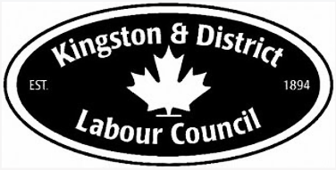

Health & Safety Workshop

Theme: Violence in the Workplace
Date: Saturday, May 2, 2026
Location: OPSEU Meeting Centre, 824 John Counter Blvd, Kingston, ON
Capacity: 25 participants

Agenda

8:30 AM — Arrival & Registration
☕Coffee and snacks
9:00 AM — Welcome & Opening
• Land Acknowledgement
• Welcome from Kingston & District Labour Council
9:15 AM — Violence in the Workplace - Worker’s Health & Safety Centre
Presenter: Christopher Gervais, Training Services Representative
10:15 AM — Break
10:30 AM — Workshop Resumes
12:30 PM — Lunch (provided)
1:15 PM — Occupational Health Clinics for Ontario Workers (OHCOW)
Presenter: Laura Lozanski, Ottawa LOC Chair, Canadian Office and Professional Employees Union (COPE) Local 225
• Overview of services and how workers can access support
3:00 PM — Break
3:15 PM — Legal Rights & Workplace Claims
Presenter: Jessica Greenwood, Lawyer, Raven Law
• Legal perspective & overview, Q&A

4:45 PM — Wrap-Up & Closing Remarks

